Max Bonke

Restrictions on subordinators in Russian and Spanish elliptical clauses

**Keywords:** verb ellipsis; clause embedding; subordinators; Russian; Spanish

In many languages, it is possible to omit the finite verb from the second of two coordinated clauses if it is identical with that of the first clause (see (1a) for an English example). This type of verb ellipsis is called gapping. One point of variation between the languages that allow gapping occurs in embedded clauses. In English, the elliptical clause may not host a subordinator such as *that*, see (1b). This restriction also holds in other languages (e.g. German, Dutch, French), but not in all of them: In Spanish and Russian, the equivalent of English *that* (Sp. *que*, Rus. *čto*) is optional in such environments. See (2) for an attested example with a subordinator in Spanish.

These observations suggest that when it comes to embedded gapping, there are two language types: English-type languages, which prohibit a subordinator, and Spanish/Russian-type languages, where the subordinator is optional. I will address the question whether the assumption of (only) these two types is justified, specifically by asking whether Spanish and Russian are indeed of the same type.

A closer look at Spanish reveals nuanced patterns of *que* in embedded gapping. Bonke/Repp’s (2022) acceptability study indicates that the presence of *que* is constrained by the type of embedding verb: Under factive verbs (i.e. verbs that presuppose the content of their complement clause), ratings significantly decrease if *que* is present compared to when it is absent (but are not so low as to indicate outright ungrammaticality). Under non-factive verbs, *que* does not significantly affect ratings. The same effect does not obtain in non-elliptical clauses, where *que* has no statistically significant effect, regardless of verb type. If Spanish and Russian are indeed of the same type, it is to be expected that the same restrictions hold in Russian.

I will contrast Bonke/Repp’s (2022) findings with the results of an equivalent acceptability study on Russian *čto*. In two experiments, participants judged the naturalness of embedded gapping structures under non-factive (Exp. 1) and factive (Exp. 2) verbs. Both experiments had a 2×2 design, with the first factor being the subordinator (present vs. absent). In keeping with Bonke/Repp’s (2022) design, the second factor contrasted gapping with stripping, i.e. verb ellipsis with a polarity particle, in this case *tože* ‘too’. The inclusion of stripping is independently motivated for Russian because there are differences between gapping and stripping in other embedded contexts (Bailyn/Bondarenko 2018). In (3) and (4) there is a sample item with the non-factive embedding verb *govorit* ‘says’ in the gapping and stripping conditions, respectively. To explore whether the results were specific to ellipsis, I tested the non-elliptical equivalents of the materials of Exp. 1 in another experiment (= Exp. 3).

The results are in Figure 1. Ratings for the individual conditions vary slighty between experiments. However, differences between conditions are largely identical in all three experiments: Except for gapping without *čto*, all conditions are degraded but not outright ungrammatical. Ratings indicate a substantial difference between the experimental conditions and unacceptable controls (not shown). The statistical analyses (mixed models) for the three experiments revealed significant effects of both factors as well as an interaction. Single comparisons revealed that the effect of *čto* is only significant within the gapping data subsets for each experiment.

The similar results for non-factives (Exp. 1) and factives (Exp. 2) suggest that verb type plays no role in the acceptability of *čto*. Instead, we find a dependency on the type of ellipsis: *Čto* causes a degradation in gapping, but not in stripping (which is degraded on the whole, independently of *čto*). A comparison of Exps. 1 and 3 furthermore suggests that, unlike in Spanish and English-type languages, the effects of the subordinator are independent of ellipsis as such: We observe the same patterns, regardless of whether the verb is absent (Exps. 1/2) or present (Exp. 3).

Thus, the restrictions on Russian *čto* are not the same as those on Spanish *que*, and the two languages cannot be subsumed under the same type. These conclusions are relevant for ellipsis theory: Gapping and stripping can be argued to involve the same structure as non-elliptical clauses in Russian, but not in Spanish (or English).

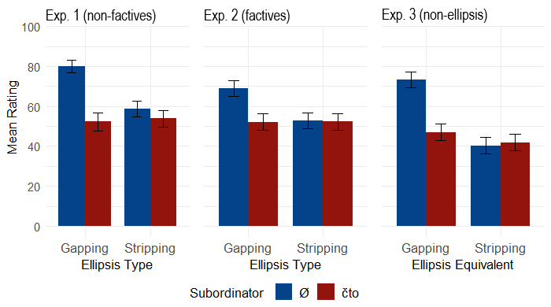Fig. 1: Experimental results (bars show mean ratings, errorbars show 95% confidence intervals)

# Examples

1. **English** **gapping**
   1. Mary orders steak and John ~~orders~~ seafood.
   2. Sue thinks that Mary orders steaks and (*that) John ~~orders~~ seafood.

|  |  |  |  |  |  |  |  |  |  |  |  |  |  |  |
| --- | --- | --- | --- | --- | --- | --- | --- | --- | --- | --- | --- | --- | --- | --- |
| 1. **Spanish gapping** (<http://www.afntijuana.info/editoriales/67101_trump_no_te_necesitamos>, last access: 24 April 2023) | | | | | | | | | | | | | | |
|  | *El* | *cree* | *que* | *el* | *mundo* | *es* | *su* | *empresa* | *y* | ***que*** | *los* | *Mexicanos* | *sus* | *lacayos.* |
|  | He | thinks | that | the | world | is | his | company | and | that | the | Mexicans | his | lackeys |
|  | ‘He thinks that the world is his company and the Mexicans his lackeys.’ | | | | | | | | | | | | | |

|  |  |  |  |  |  |  |  |  |  |  |  |  |
| --- | --- | --- | --- | --- | --- | --- | --- | --- | --- | --- | --- | --- |
| 1. **Sample item for gapping** (Exp. 1) | | | | | | | | | | | | |
|  | *Maša* | *govorit,* | *čto* | *koška* | *est* | *žarenuju* | *kuricu* | *a* | *{čto|Ø}* | *sobaka* | ***–*** | ***kotlety****.* |
|  | Masha | says | that | cat | eats | Fried | chicken | and | that|Ø | dog |  | cutlets |
|  | ‘Masha says that the cat eats fried chicken and the dog cutlets.’ | | | | | | | | | | | |

|  |  |  |  |  |  |  |  |  |  |  |  |  |
| --- | --- | --- | --- | --- | --- | --- | --- | --- | --- | --- | --- | --- |
| 1. **Sample item for stripping** (Exp. 1) | | | | | | | | | | | | |
|  | *Maša* | *govorit,* | *čto* | *koška* | *est* | *žarenuju* | *kuricu* | *i* | *{čto|Ø}* | *sobaka* | ***–*** | ***tože****.* |
|  | Masha | says | that | cat | eats | fried | chicken | and | that|Ø | dog |  | too |
|  | ‘Masha says that the cat eats fried chicken and the dog, too.’ | | | | | | | | | | | |

References

Bailyn, John Frederick/Bondarenko, Tatiana (2018): Russian. In: Craenenbroeck, Jeroen van/ Temmerman, Tanja (eds.): The Oxford Handbook of Ellipsis. Oxford: Oxford University Press, pp. 988–1019. <https://doi.org/10.1093/oxfordhb/9780198712398.013.36>.

Bonke, Max/Repp, Sophie (2022): Complementizer deletion in embedded gapping in Spanish. In: The Linguistic Review, 39(3), pp. 525–555. <https://doi.org/10.1515/tlr-2022-2096>.

# Contact information

**Max Bonke**

Universität zu Köln

[mbonke@uni-koeln.de](mailto:mbonke@uni-koeln.de)