Lutz Gunkel/Jutta M. Hartmann

Prepositional object clauses in West Germanic.
Experimental evidence from wh-movement
Keywords: prepositional object clause, wh-movement, island, experimental syntax, West Germanic
The issue: We discuss (declarative) prepositional object clauses (PO-clauses) in the West Germanic languages Dutch (NL), German (DE), and English (EN). In Dutch and German, PO-clauses occur with a prepositional proform (=PPF, Dutch: ervan, erover, etc.; German: drauf/darauf, drüber/darüber, etc.). This proform is optional with some verbs (1). In English, by contrast, P embeds a clausal complement in the case of gerunds or indirect questions (2), however, P is obligatorily absent when the embedded CP is a that-clause in its base position (3a). However, when the that-clause is passivized or topicalized, the stranded P is obligatory (3b). Given this scenario, we will address the following questions: (i) Are there structural differences between PO-clauses with a P/PPF and those in which the P/PPF is optionally or obligatorily omitted? (ii) In particular, do PO-clauses without P/PPF structurally coincide with direct object (=DO) clauses? (iii) To what extent are case and nominal properties of clauses relevant? We use wh-extraction as a relevant test for such differences.
Previous research: Based on pronominalization and topicalization data in German and Dutch, PO-clauses are different from DO-clauses independent of the presence of the PPF (see, e.g., Breindl 1989, Zifonun et al. 1997, Berman 2003, Broekhuis/Corver 2015 and references therein (4,5). English pronominalization and topicalization data (3b) appear to point in the same direction (Fischer 1997, Berman 2003, Delicado Cantero 2013). However, the obligatory absence of P before that-clauses in base position indicates a convergence with DO-clauses.
Experimental evidence: To provide further evidence to these questions we tested PO-clauses in all three languages for long wh-extraction, which is usually possible for DO-clauses in English and Dutch, and in German for southern regional varieties. For German and Dutch we conducted rating studies using the thermometer method (Featherston 2008). Each study contained two sets of sentences: the first set tested long wh-extraction with regular DO-clauses (6). The second set tested wh-extraction from PO-clauses with and without PPFs (7), respectively. The results show no significant difference in extraction with PO-clauses whether or not the PPF was present even for those speakers who otherwise accept long-distance extraction in German. This supports a uniform analysis of PO-clauses with and without the PPF in contrast to DO-clauses. For English we tested extraction with verbs that select for PP-objects in two configurations: V+that-clause and V+P-gerund (8) in comparison to sentences without extraction. Participants rated sentences on a scale of 1 (unnatural) to 7 (natural). We included the gerund for English as this is a regular alternative for such objects. The results show that extraction is licit in both configurations. This suggests that English PO-clauses are different from German and Dutch PO-clauses: They rather behave as DO-clauses allowing for extraction. Note though, that the availability of extraction from P+gerund also shows that PPs are not islands for extraction in English. Overall, this shows that there is a split between English vs. German/Dutch PO-clauses when the P/PPF is absent. While these clauses behave like PO-clauses in the latter languages, extraction does not show a difference between DO- and PO-clauses in English. We will discuss the results in relation to the questions (i)-(iii) above.
Examples:
(1) a. Jan klaagt (erover) dat Marie zijn aantekeningen weggegooid heeft. [NL]
b. Hans klagt (darüber), dass Maria seine Aufzeichnungen weggeworfen hat. [DE]
J./H. complains about-it that M. his notes away-thrown has
(2) a. The minister worries about losing votes.
b. I mean, don’t you feel worried having to walk back to your flat in that part of town? (books.google.de)
c. We can't agree (on) whether that is the best choice (Delicado Cantero 2013: 33)
(3) a. She insisted (*on) that he was innocent.
b. That he is innocent was insisted *(on) (by her). (adapted from Fischer 1997: 193)
(4) a. Dat Marie de aantekeningen heeft weggegooid, beweerde Hans. [DO, NL]
that M. the notes (has) away-thrown claims H.
b. Dass Maria die Aufzeichnungen weggeworfen hat, behauptet Hans. [DO, DE]
that M. the notes away-thrown has claims H.
(5) a. *Dat Marie zijn aantekeningen heeft weggegooid, klaagt Jan (erover). [PO, NL]
b. *Dass Maria seine Aufzeichnungen weggeworfen hat, klagt Hans (darüber). [PO, DE]
(6) %Welchen Priester denkt er, dass der Bischof ermahnt hat? [DO, DE]
which priest thinks he, that the bishop admonished has
(7) *Welches Pony haben wir uns (darüber) gefreut, dass die Kinder streicheln dürfen? [PO, DE]
which pony have we refl about-it happy-be, that the kids stroke may
(8) Which award did the actress dream {that she won}/{of winning}?
References:
Berman, J. (2003): Clausal Syntax of German. Stanford, CA
Breindl, E. (1989): Präpositionalobjekte und Präpositionalobjektsätze im Deutschen. Tübingen
Broekhuis, H. & N. Corver (2015): Syntax of Dutch. Verbs and Verb Phrases. Vol. 2. Amsterdam
Delicado Cantero, M. (2013): Prepositional Clauses in Spanish. Berlin
Featherston, S. (2008): Thermometer judgements as linguistic evidence. In: Riehl, C. Maria/Rothe, A. (ed.) (2008): Was ist linguistische Evidenz? Aachen. 69–90
Fischer, K. (1997): German-English Verb Valency. Tübingen
Huddleston, R. D./Pullum, G. K. (2002): The Cambridge Grammar of the English Language. Cambridge
Zifonun, G./Hoffmann, L./Strecker, B. et al. (1997): Grammatik der deutschen Sprache. Vol. 2. Berlin
Experimental results for wh-extraction:
German DO-clauses per group  (1=accepting extraction, 2= rejecting extraction) | Dutch DO-clauses per group  (1=rejecting extraction, 2= accepting extraction)
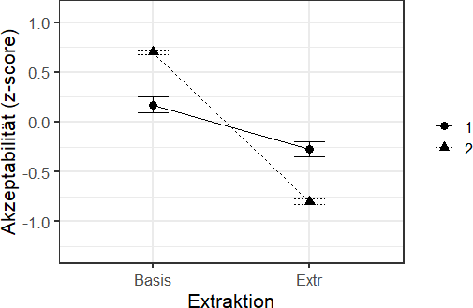 | 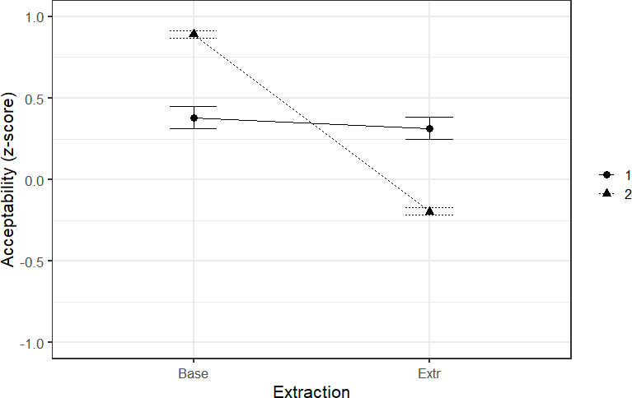
German PO-clauses Group 1 with and without proform | Dutch PO-clauses Group 2 with and without proform
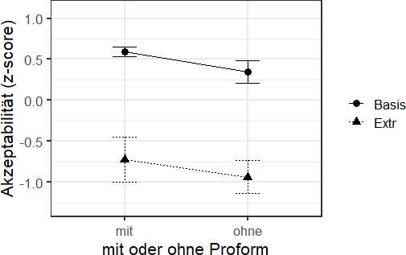 | 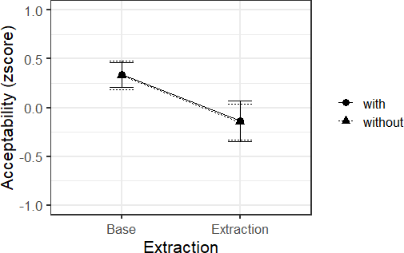
German PO-clauses group 2 with and without proform | Dutch PO-clauses Group 1 with and without proform
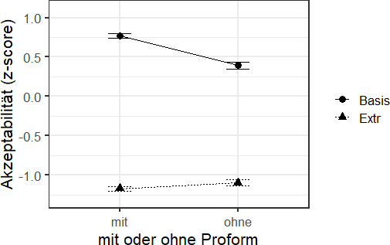 | 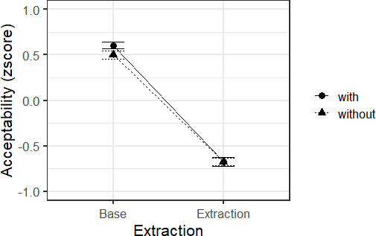
Wh-extraction from English PO-clauses contrasting that-clauses without P vs. Gerunds with P

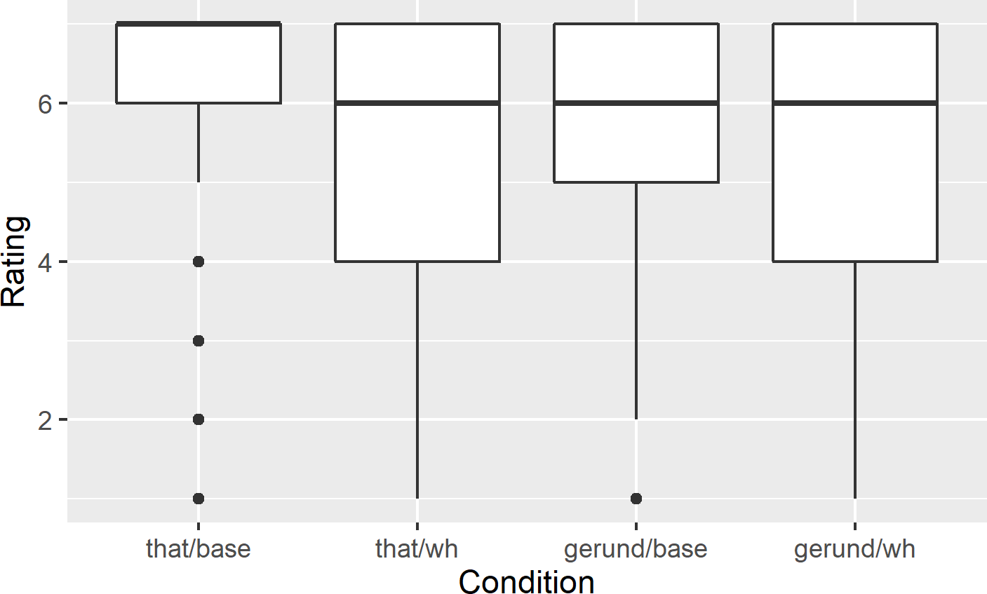
Contact information
Lutz Gunkel
Leibniz-Institut für Deutsche Sprache
gunkel@ids-mannheim.de
Jutta M. Hartmann
Universität Bielefeld
jutta-maria.hartmann@uni-bielefeld.de

