Alexandra Gubina/Emma Betz/Carmen Taleghani-Nikazm/Reihaneh Afshari Saleh

Marking something as unexpected:

Prosodically marked ‘no’ in German and Persian

**Keywords:** negation particle; newsmark; affective stance; prosody; expectation; affiliation; stance management; German; Persian

This conversation analytic study compares the use of negation particles in spoken German and Persian, namely *nein/nee* and *na*. While these particles have a range of functions in both languages (Ghaderi 2022; Imo 2017), their use in response to news remains understudied. We focus on *nein/nee* and *na* in two sequential contexts: (i) after prior disconfirmations (Extract (a)) and (ii) in response to either solicited or unsolicited informings (see Extracts (b) and (c), respectively).

In both contexts, *nein/nee* and *na* mark unexpectedness and open up an opportunity space for more, but they do so in different ways and with different outcomes. *Nein/nee*- and *na*-turns after disconfirming, often minimal responses to first-position confirmable turns mark the prior as unexpected (or even contrasting with the *nein/nee/na*-speaker’s expectations) and thus as expandable/accountable (cf. Ford 2001; Gubina/Betz 2021). *Nein/nee/na*-turns after informings (e.g., announcements that display a story teller’s negative emotional stance) differ not only in sequential position but also in prosodic realization. They can be either falling or rising, but all are characterized by marked prosody, i.e., lengthening, very low onset, smiling or breathy voice, or high overall pitch. Through position and turn design features, such *nein/nee-* and *na*-turns not only mark a prior turn as counter to (normative) expectations, but may also display the speaker’s affective stance and affiliate with the affective stance of the prior interactant.

By comparing the use of *nein/nee* and *na* in German and Persian in the two functions illustrated in Extracts (a) and (b/c), we will show (i) how *nein/nee*- and *na*-turns shape interactional trajectories after responsive actions and (ii) what role the particles play in managing news and stance-taking as well as epistemic and affective positioning. Apart from revealing similarities in the use of German and Persian negation particles, the results of our cross-linguistic comparison will demonstrate that even if different languages have similar practices for specific actions, the use of these practices is language- and culture-specific. This means that even similar practices in different languages have their own “collateral effects” (Sidnell/Enfield 2012), linguistic and prosodic characteristic features, and, at least sometimes, consequences for social actions accomplished in the specific language (e.g., Dingemanse et al. 2014; Evans/Levinson 2009; Floyd et al. 2020; Fox et al. 2009).

Our study uses the method of Conversation Analysis (Sidnell/Stivers 2013) and draws on more than 80 hours of audio and video recordings of spontaneous interactions (co-present, via video link, and on the telephone) in everyday and institutional contexts.

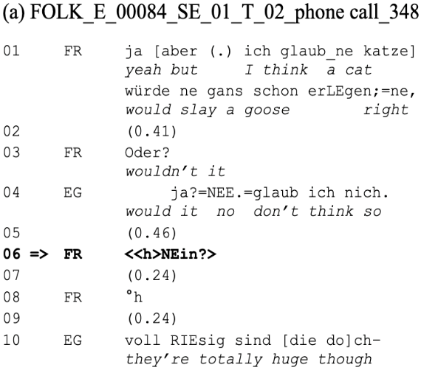

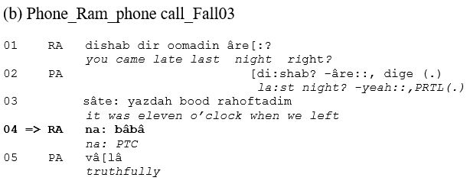

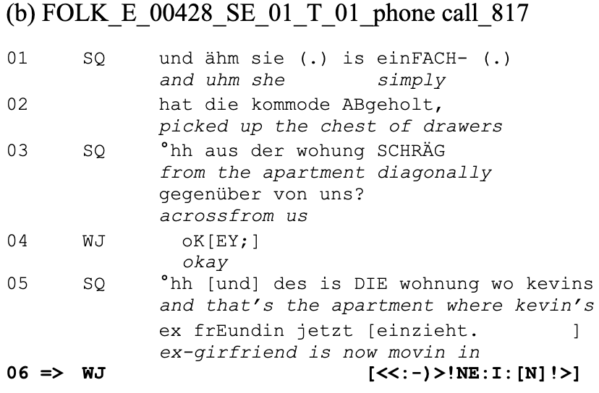

(c) FOLK_E_00428_SE_01_T_01_phone call_817

References

Dingemanse, Mark/Blythe, Joe/Dirksmeyer, Tyko (2014): Formats for Other-Initiation of Repair across Languages: An Exercise in Pragmatic Typology. In: Studies in Language,38: pp. 5–43.

Evans, Nicholas/Levinson, Stephen C. (2009): The Myth of Language Universals: Language Diversity and Its Importance for Cognitive Science. In: Behavioral and Brain Sciences, 32, pp. 429–448.

Floyd, Simeon/Rossi, Giovanni/Enfield, Nick J. (eds.) (2020): Getting Others to Do Things: A Pragmatic Typology of Recruitments. Berlin: Language Science Press.

Ford, Cecilia E. (2001): At the intersection of turn and sequence: Negation and what comes next. In: Selting, Margret/Couper-Kuhlen, Elisabeth (eds.): Studies in Interactional Linguistics. Amsterdam: John Benjamins, pp. 51–79.

Fox, Barbara A./Wouk, Fay/Hayashi, Makoto/Fincke, Steven/Tao, Liang/Sorjonen, Marja-Leena/Laakso, Minna/Hernandez, Wilfrido F. (2009): A Cross-Linguistic Investigation of the Site of Initiation in Same-Turn Self-Repair. In: Sidnell, Jack (ed.): Conversation Analysis: Comparative Perspectives. Cambridge: Cambridge University Press, pp. 60–103.

Ghaderi, Soleiman (2022): Outside the clause: Functions of the Persian na ‘no’. In: Journal of Pragmatics, 197, pp. 100-117.

Gubina, Alexandra/Betz, Emma (2021): What do newsmark-type responses invite? The response space after German *echt*. In: Research on language and social interaction 54, pp. 374–396.

Imo, Wolfgang (2017): Über *nein*. In: Zeitschrift für germanistische Linguistik 45, pp. 40–72.

Sidnell, Jack/Enfield, Nick J. (2012): Language Diversity and Social Action: A Third Locus of Linguistic Relativity. Current Anthropology53, pp. 302–333.

Sidnell, Jack/Stivers, Tanya (eds.) (2013): The Handbook of Conversation Analysis. Chichester, UK: Wiley-Blackwell.

# Contact information

**Alexandra Gubina**

Leibniz-Institut für Deutsche Sprache

[gubina@ids-mannheim.de](mailto:gubina@ids-mannheim.de)

**Emma Betz**

University of Waterloo

[embetz@uwaterloo.ca](mailto:embetz@uwaterloo.ca)

**Carmen Taleghani-Nikazm**

The Ohio State University

[taleghani-nikazm.1@osu.edu](mailto:taleghani-nikazm.1@osu.edu)

**Reihaneh Afshari Saleh**

Ulster University

[r.afshari-saleh@ulster.ac.uk](mailto:r.afshari-saleh@ulster.ac.uk)