Hagen Augustin / Dániel Czicza / Lutz Gunkel / Susan Schlotthauer / Kerstin Schwabe / Beata Trawiński / Angelika Wöllstein

Propositional arguments in English, German, Hungarian, Italian and Polish

**Keywords:** Propositional Argument; Clause Union; English; German; Hungarian; Italian; Polish

Background and Goal:

In many European languages, propositional arguments (PAs) can be realized as different types of structures. Cross-linguistically, complex structures with PAs show a systematic correlation between the strength of the semantic bond and the syntactic union (cf. Givón 2001, Wurmbrand/Lohninger 2020). Also, different languages show similarities with respect to the (lexical) licensing of different PAs (cf. Noonan 1985, Givón 2001, Cristofaro 2003 on different predicate types). However, on a more fine-grained level, a variation across languages can be observed both with respect to the syntactic-semantic properties of PAs as well as to their licensing and usage. This presentation takes a multi-contrastive view of different types of PAs as syntactic subjects and objects by looking at five European languages: EN, DE, IT, PL and HU. Our goal is to identify the parameters of variation in the clausal domain with PAs and by this to contribute to a better understanding of the individual language systems on the one hand and the nature of the linguistic variation in the clausal domain on the other hand.

Phenomena and Methodology: We investigate the following types of PAs: direct object (DO) clauses (1), prepositional object (PO) clauses (2), subject clauses (3), and nominalizations (4, 5). Additionally, we discuss clause union phenomena (6, 7). The analyzed parameters include among others finiteness, linear position of the PA, (non‑) presence of a correlative element, (non‑) presence of a complementizer, lexical-semantic class of the embedding verb. The phenomena are analyzed based on corpus data (using mono- and multilingual corpora), experimental data (acceptability judgement surveys) or introspective data.

Selected Results:

i. As to finite DO clauses, they may exhibit complementizers that indicate subordination. Whereas DE *dass*/*ob*, EN *that*/*whether*/*if*, IT *che*/*se*, and PL *że*(*by*)/*czy* indicate additionally a clause type, HU *hogy* only marks subordination. While *that*, *che* und *hogy* are omissible under certain conditions, *dass* and *że*(*by*) are not. Regarding infinite clauses, DE and HU do not have any complementizer contrary to EN *for*/*whether*, IT *di*/*se* and PL *żeby*/*czy*. In DE, EN, IT, and HU, there are infinitives co-occurring with an accusative NP, forming thus a small clause. In PL, on the other hand, the accusative NP co-occurs with a present participle, just like in EN gerundial constructions.

ii. The main variation parameter in the field of PO clauses concerns the way the preposition is syntactically realized: it attaches either to the clause directly or to a pro-form, which syntactically relates to the clause. In the first case, a PO containing a clause is analogous to one containing an NP (North Germanic and Romance). In contrast to the latter case, prepositions in clausal POs can or must often be omitted. Since an omitted preposition can be made “visible” under certain conditions, EN and IT are to be subsumed under this type as well, e.g., (2), Gunkel/Hartmann (2020, 2021). In the second case, pronouns (HU, PL and other Slavic languages) or adverbs (DE) appear as pro-forms. Here, the main intra- and interlingual variation concerns the question, whether or not the pro-form forms a constituent together with the clause.

iii. The behavior of clausal subjects is very consistent across the compared languages as far as their pre-/post-verbal position and the embedding predicates are concerned. In all languages, cognition and emotion predicates occur most frequently with post-verbal subject clauses (3a), whereas the connective predicates show preferences for preverbal position (3b), (Fig. 1). This can be explained by the difference in the argument/thematic structure underlying these verb classes (experiencer=object / stimulus=subject vs. cause=subject / effect=object) (cf. Haiman 1980, Kaltenböck 2004, Diessel 2008 on the logical order of events and iconicity of sequence).

iv. In all languages investigated, PAs can be realized by expressions that show nominal properties (e. g. nominalized infinitives (4a, 5a), gerunds, verbal nouns). These are, to some extent, able to preserve verbal internal structures (5a). As with verbal PAs, complex structures with nominalized PAs can show a systematic correlation between both syntactic and semantic dimensions, although the mechanisms of verbal and nominal argument linking, and realization preferences are subject to variation both across and within languages (4, 5).

v. In a cross-linguistic perspective, there is a tendency for verbs of modality and evidentiality as well as temporal auxiliaries to undergo clause union. However, focusing on syntax, we must deal with different language features and, what's more, with diverging criteria used to posit a close or a loose connection between verbs constituting a verbal complex. HU modal *kell*, for instance, allows a finite clause with a complementizer (7), whereas corresponding DE *müssen* governs bare infinitive of the full verb (6).

Conclusions: The results confirm the hypothesis of the correlation between the syntactic and semantic dimensions of structures with PAs at a general level. At the same time, they show a number of variations on closer inspection.

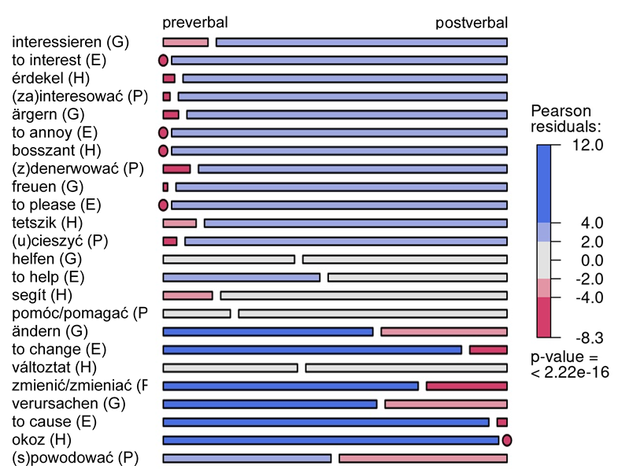Fig. 1:

# Examples

(1) I think [that you may be right].

(2) a. She insisted that he was innocent.  
b. That he is innocent was insisted on (by her).

(3) a. Then it pleases me to be the first.  
b. My son, to see you again causes my heart to soar like a hawk.

|  |  |  |  |  |  |  |  |
| --- | --- | --- | --- | --- | --- | --- | --- |
| 1. DE | | | | | | | |
|  | a. | Das DRK ruft zum Spenden von Blut / zum Blutspenden auf. | | | | | |
|  |  | ‘The German Red Cross calls for donating blood.’ | | | | | |
|  |  | *zum* | *Spenden* | *\*(von)* | *Blut* | / | *Blutspenden* |
|  |  | for:the:m | donate:inf | of | blood |  | blood_donate:inf |
|  | b. | […] ruft zur Spende von Blut / zur Blutspende auf. | | | | | |
|  |  | *zur* | *Spende* | *\*(von)* | *Blut* | / | *Blutspende* |
|  |  | for:the:f | donation | of | blood |  | blood_donation |

|  |  |  |  |  |  |
| --- | --- | --- | --- | --- | --- |
| 1. IT | | | | | |
|  | a. | La terapia iperbarica consiste nel respirare ossigeno puro. | | | |
|  |  | ‘Hyperbaric therapy consists of breathing pure oxygen.’ | | | |
|  |  | *nel* | *respirare* | (\**di*) | *ossigeno* |
|  |  | in:the:m | breath:inf | of | oxygen |
|  | b. | […] consiste nella respirazione di ossigeno puro. | | | |
|  |  | *nella* | *respirazione* | *(*di*) | *ossigeno* |
|  |  | in:the:f | respiration | of | oxygen |

|  |  |  |  |  |  |
| --- | --- | --- | --- | --- | --- |
| 1. DE | | | | | |
|  | *Ich* | *muss* | *diesen* | *Film* | *gucken.* |
|  | 1sg | must;1sg | this | film | watch:inf |
|  | ‘I must watch this film.’ | | | | |

|  |  |  |  |  |  |  |  |
| --- | --- | --- | --- | --- | --- | --- | --- |
| 1. HU | | | | | | | |
|  | *Meg* | *kell* | *hogy* | *nézzem* | *ezt* | *a* | *filmet.* |
|  | part | must | comp | watch:sbjv:1sg.def | this:acc | the | film:acc |
|  | ‘I must watch this film.’ | | | | | | |

References

Cristofaro, S. (2003): Subordination. Oxford and New York.

Diessel, H. (2008): Iconicity of sequence: A corpus-based analysis of the positioning of temporal adverbial clauses in English. In: Cognitive Linguistics, 19(3), pp. 465–490. <https://doi.org/10.1515/COGL.2008.018>.

Givón, T. (2001): Syntax. An introduction. Vol. I/II. Amsterdam and Philadelphia.

Gunkel, L./Hartmann, J. M. (2020): Remarks on prepositional object clauses in Germanic. In: Nordlyd: Tromsø University Working Papers on Language & Linguistics, 44(1), pp. 69–91. <https://doi.org/10.7557/12.5244>.

Gunkel, L./Hartmann, J. M. (2021): Präpositionalobjektsätze im europäischen Vergleich. In: Lobin, Henning/Witt, Andreas/Wöllstein, Angelika (eds.): Deutsch in Europa. Berlin and Boston, pp. 111–133.

Haiman, J. (1980): The iconicity of grammar. Isomorphism and motivation. In: Language, 56(3), pp. 515–540.

Kaltenböck, G. (2004): It-extraposition and non-extraposition in English: A study of syntax in spoken and written texts. Wien.

Noonan, M. (1985): Complementation. In: Shopen, T. (ed.): Language typology and syntactic description. Cambridge, pp. 41–140.

Wurmbrand, S./Lohninger, M. (2022): An implicational universal in complementation - Theoretical insights and empirical progress. In: Hartmann, J. M./Wöllstein, A. (eds.): Propositionale Argumente im Sprachvergleich / Propositional arguments in cross-linguistic research. Tübingen, pp. 183–229.

# Contact information

**H. Augustin, D. Czicza, L. Gunkel, S. Schlotthauer, K. Schwabe, B. Trawiński, A. Wöllstein**

[*surname*@ids-mannheim.de](mailto:surname@ids-mannheim.de)

Leibniz-Institut für Deutsche Sprache