Anne-Kathrin Gärtig-Bressan

Verbs for expressing the modification of objects
Lexicalisation strategies and preferences in German and Italian
Keywords: Lexicalization patterns; drying and cleaning events; modification of an object; linguistic typology; Imagact ontology; German and Italian action verbs
Since Talmy (cf. 1985) we know that languages show very different lexicalisation preferences when verbalising motion events and that Italian, as a Romance language, prefers to express the direction of movement, path in Talmy’s terms, in its verbs (e.g. in salire), whereas German, as a Germanic language, tends to outsource this semantic component to a satellite and encodes the type of movement (manner) in the verb itself instead (e.g. in hinaufgehen). Following on, studies on other semantic classes of action verbs (cf. e.g. Talmy 2000; Herslund 2007; Korzen 2016 and 2018) have shown that Germanic languages also have a high “manner salience” (Slobin 2004) in this verbs, while Romance languages tend to focus on the result of an action and prefer generic verbs (cf. Moneglia & Panunzi 2010) with a high extension for many actions, which are characterised precisely by the absence of the manner component (cf. Korzen 2018). Also, German verbs seem to have a higher variation in expressing concrete actions, not least due to its possibilities of verbal word formation with preverbs (besides wischen, for example, we find abwischen, aufwischen, wegwischen, cf. Donalies 2011).
The proposed paper takes a look at the semantic subclass of verbs for expressing the modification of an object and specifically for expressing drying and cleaning events, which are particularly characterised by the semantic components manner (How is an object cleaned/dried?) and result (What is the processed object like after the action?). It asks not only what kind of verbs or verbal expressions with what semantic features the two languages provide for this subclass, but rather what kind of verbs speakers of German and Italian actually prefer in a given context.
To this end, an online experiment was conducted between 2019 and 2020 in which the participating test subjects were shown a total of 20 short videos or animations in which a person could be seen performing a specific activity. For each video, the participants were asked to answer the simple question: What is the person you see doing? The sample drawn consisted of 30 test persons per language, originating from different regions of the Italian and German speaking areas and comparable in terms of age and educational background. For this study, their response sentences to a total of nine videos (see figure 1) showing a person cleaning or drying an object were evaluated. There were therefore 270 responses per language.
The research questions were: What variation can be found in the verbalisation of drying and cleaning events by verbs in German and Italian? Which semantic features are encoded particularly frequently by the languages in each case and in which part of the verbal expression (especially for German, more in the base verb or in the satellite) and what role do the different word formation possibilities play in this?
The evaluation yielded the following results: The German sample uses a total of 43 verbs or verbal expressions to describe the nine short video animations, while the Italian sample uses only 24 for the same scenes. The variation is thus significantly higher in German, which is also related to the different verbal word formation possibilities of this language.
As expected, the German verbs prefer to express the manner component. A total of 69.6% of the verbs mentioned contain it, alone (24.8%) or in combination with other components (besides result, also privation, among others). In contrast, the component result is most frequent among the Italian verbs. It is found in a total of 48.1% of the answers, in 45.9% as the only component, namely in the high-frequency general verbs asciugare and pulire. German combines semantic features in its (complex) verbs significantly more often than Italian. In the German sample, the responses contain an average of 1.5 features, in Italian 1.1.
Awareness of these different lexicalisation strategies is of high importance also for the applied disciplines closely related to contrastive linguistics, such as foreign language teaching and translation and its didactics.

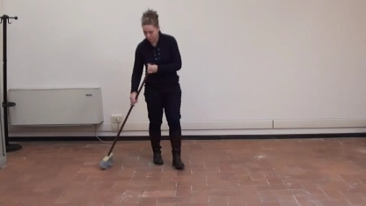  Scene 1 | 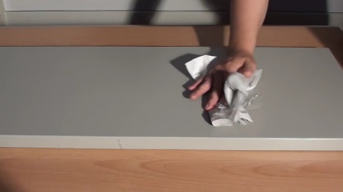  Scene 2 |   Scene 3
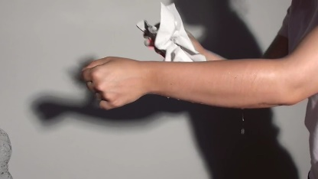  Scene 4 | 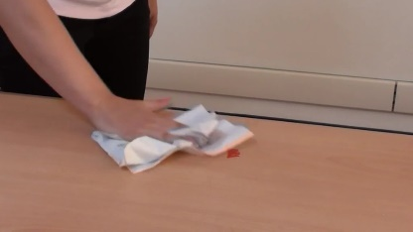  Scene 5 | 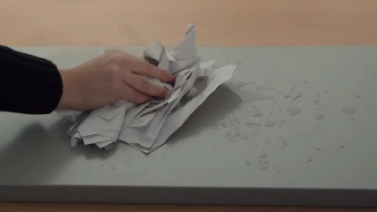  Scene 6
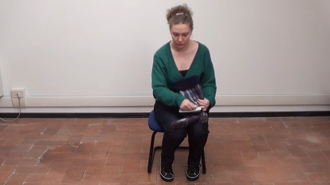  Scene 7 | 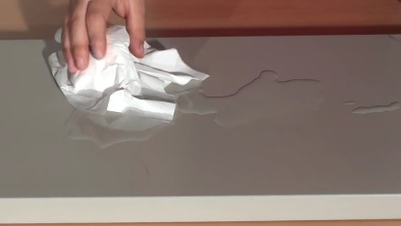  Scene 8 | 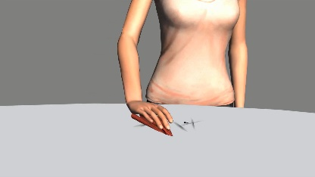  Scene 9
Fig. 1: Scenes drying and cleaning-events (www.imagact.it)

References
Donalies, Elke (2011): Basiswissen Deutsche Wortbildung. Zweite, überarbeitete Auflage, Tübingen/Basel: Francke.
Gärtig-Bressan, Anne-Kathrin (2022): Verben zum Ausdruck der Modifikation von Objekten – Lexikalisierungsstrategien und Präferenzen im Deutschen und Italienischen. In: Rivista internazionale di tecnica della traduzione, 24, pp. 283–312.
Herslund, Michael (2007): Lexikalische Typologie – Dänisch und Französisch als endo- bzw. exozentrische Sprachen. In: Skandinaviske sprogstudier, 5, pp. 1-13.
Korzen, Iørn (2016): Endocentric and Exocentric Verb Typology: Talmy Revisited – on Good Grounds. In: Language and Cognition, 8 (2), pp. 206-236.
Korzen, Iørn (2018): L’italiano: una lingua esocentrica. Osservazioni lessicali e testuali in un’ottica tipologico-comparativa. In: Korzen, Iørn (ed.): La linguistica italiana nei Paesi Nordici. Pisa: Pacini (=Studi Italiani di Linguistica Teorica e Applicata, 47 (1)), pp. 15-36.
Moneglia, Massimo/Panunzi, Alessandro (2010): I verbi generali nei corpora di parlato. Un progetto di annotazione semantica cross-linguistica. In: Cresti, Emanuela/ E. Cresti & Korzen, Iørn (ed.): Language, Cognition and Identity. Extensions of the endocentric/exocentric language typology. Firenze: FUP, pp. 27-45.
Slobin, Dan I. (2004): The many ways to search for a frog: Linguistic typology and the expression of motion events. In: Strömqvist, Sven/Verhoeven, Ludo (eds.): Relating events in narrative: Typological and contextual perspectives. Mahwah, NJ: Lawrence Erlbaum Associates, pp. 219-257.
Talmy, Leonard (1985): Lexicalization Patterns: Semantic Structure in Lexical Forms. In: Shopen, Timothy (ed.): Language Typology and Syntactic Description. Cambridge: The University Press, vol. III, pp. 57-149.
Talmy, Leonard (2000): Toward a Cognitive Semantics. Vol. 2, Typology and process in concept structuring, Cambridge, Mass./London: The MIT Press.

Contact information
Anne-Kathrin Gärtig-Bressan
Università degli Studi di Trieste
Dipartimento di Scienze Giuridiche, del Linguaggio, dell’Interpretazione e della Traduzione
akgaertig@units.it

